
Tripoli Motor Testing Division
223 NC Highway 54 West
Chapel Hill, NC 27514
(919) 357 5681 (c)
August 13, 2022

Gary Rosenfield
RCS Rocket Motor Components, Inc.
2113 West 850 North Street
Cedar City, UT 84721

Dear Mr. Rosenfield,

The Aerotech K1800ST-P motor was tested on August 13, 2022 and is in compliance with NFPA 1125. The motor is certified for hobby rocketry use by the members of the Tripoli Rocketry Association and all approving organizations with reciprocal certifying agreements.

Motor Manufacturer Aerotech Division, RCS Rocket Motor Components
Manufacturer’s Designation K1800ST-P S [75/2560 hardware]
Propellant Super Thunder
TMT Nomenclature 2443 K1776

Diameter 2.960” 75.18 mm
Overall Length 15.828” 402.0 mm
Length Inside 15.062” 383.6 mm
Length Outside 0.766” 19.45 mm

Loaded Mass 6.11 lb 2771.5 g
Propellant Mass 2.454 lb* 1113 g*
Burnout Mass 3.494 lb 1584.6 g
* data provided by manufacturer

Burn time 1.374 ± .011 sec

Total Impulse 549.36 ± 3.136 lbf.s 2443.7 ± 13.96 N.s
Max Impulse 468.13 ± 1.868 lbf 2082.4 ± 8.29 N
Average Impulse 399.37 ± 4.97 lbf 1776.5 ± 22.13 N
Number of Motors Tested 3

Nominal Measured
Delay Time Data n.a. n.a.

Casing Temp. [NFPA 1125 7.4.1] Passed

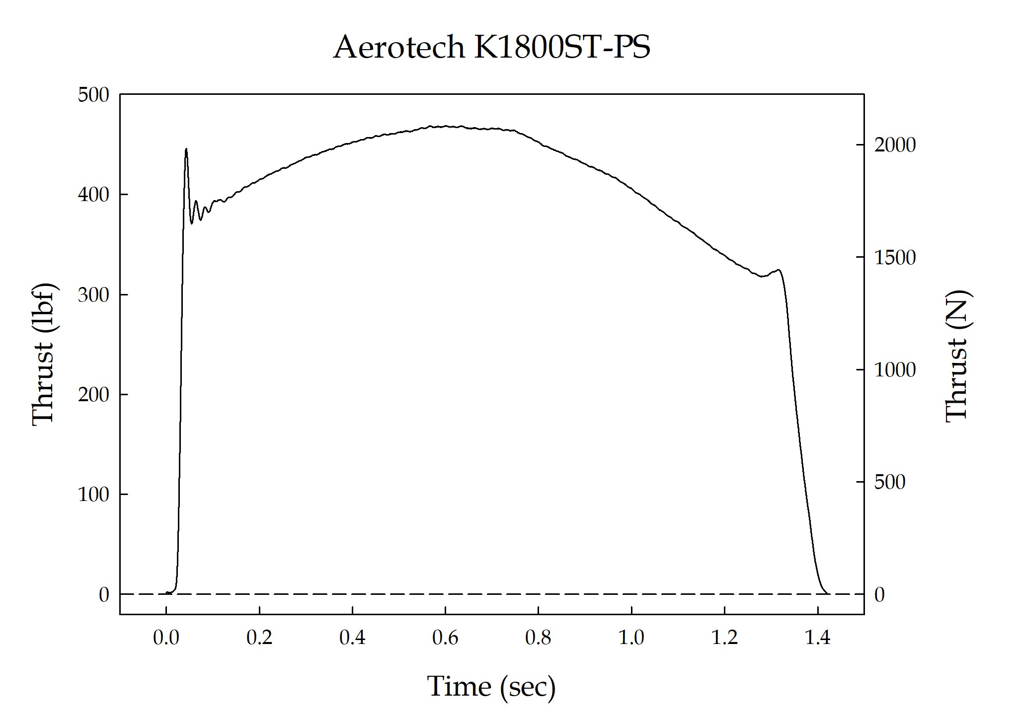

Sincerely,

Alan C. Whitmore
Chair, Tripoli Motor Testing

